1. Create a bash script to **check if a directory is available or not**.

Create a bash file with extension bash/.sh

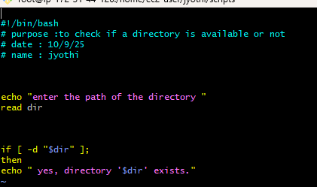

Change the permissions to 755 to the file

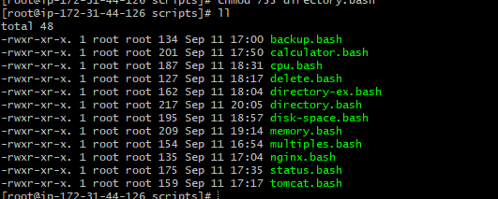

2.Create a bash script to **create multiple files**.

Create a file with extension of bash.sh

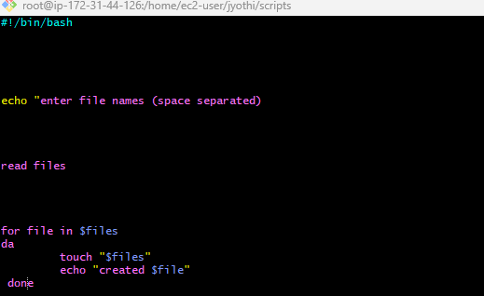

Change the permissions to chmod 755 directory.bash

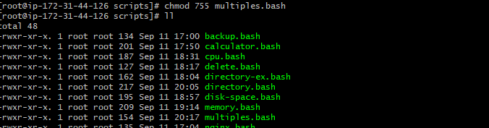

3.Create a bash script to **take a backup of a directory**.

Create a file with extension of bash.sh

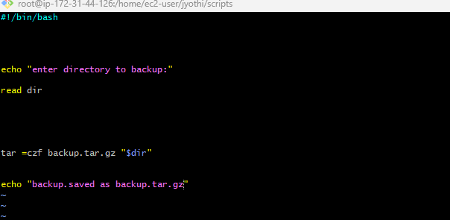

Change the permissions to chmod 755 backup.bash

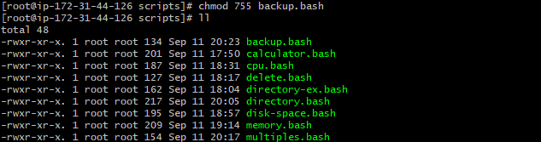

4.Create a bash script to **install Nginx on an EC2 server**.

Create a file with extension of bash.sh

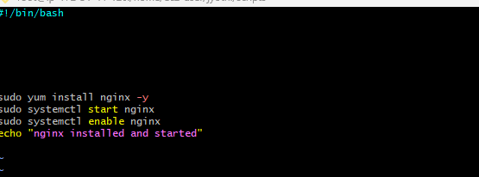

Change the permissions to chmod 755 nginx.bash

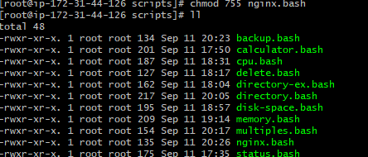

5.Create a bash script to **install Apache Tomcat on an EC2 server**.

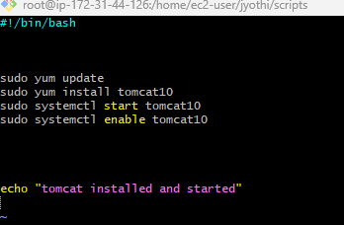

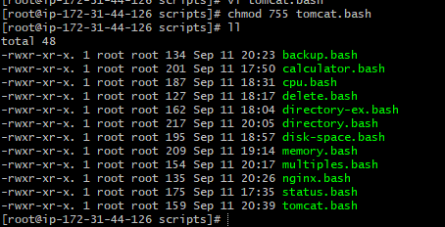

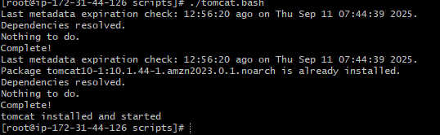

6.Create a bash script to **check if the Nginx service is running**, if not running then script should start the service.

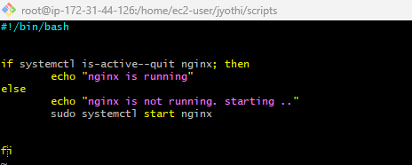

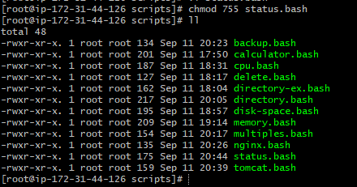



7.Create a bash script for a **calculator**.

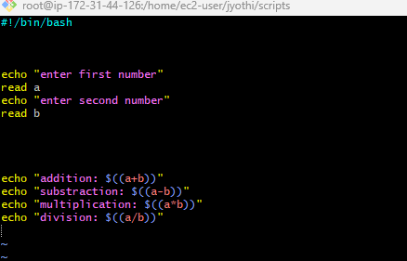

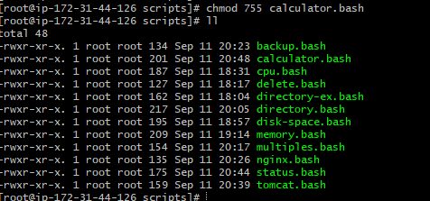

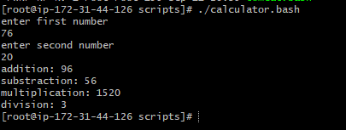

8.Create a bash script to **check if a directory exists**, if not then create a directory.

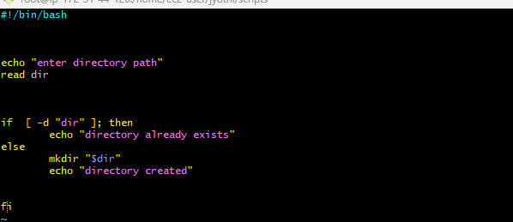

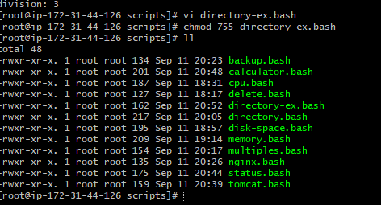

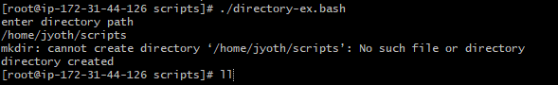

9.Create a bash script to **delete the last 3 lines of a file**.

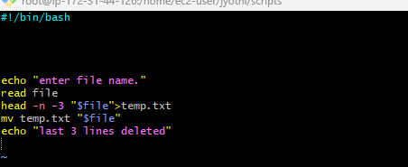

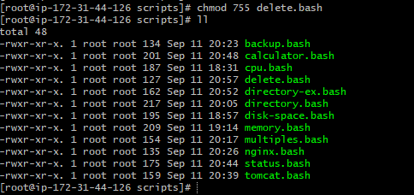

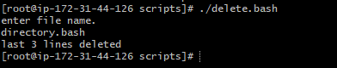

10.Bash script to monitor cpu and if it is more than 80% then send email notification.

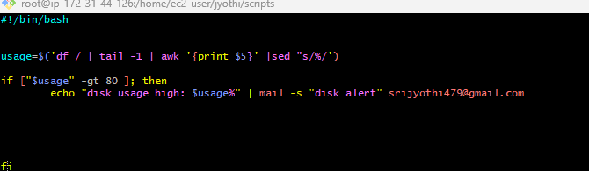

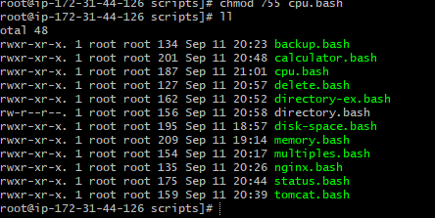

11.Bash script to monitor disk space and if it is more than 80% then send email notification.

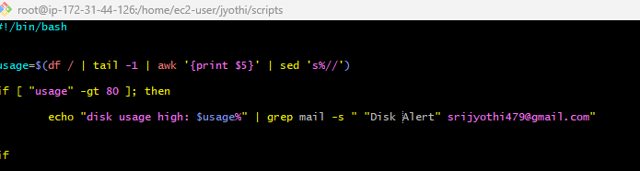

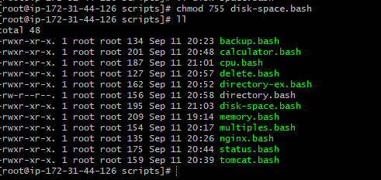

12.Bash script to monitor memory and if it is more than 80% then send email notification.

